**If Else Assignments**

**Questions :--**

1. **WAP to find a year is leap year or not (Hint: 400, 100 and 4)?**

**Ans:**

**import** java.util.Scanner;

**public** **class** leap_year {

**public** **static** **void** main(String[] args) {

Scanner in = **new** Scanner(System.***in***);

**int** year;

System.***out***.println("Enter year want to check: ");

year = in.nextInt();

**if**(year % 4 == 0){

System.***out***.println("The year is leap year!");

}

**else**{

System.***out***.println("Not a leap year!");

}

in.close();

}

}

**OUTPUT**

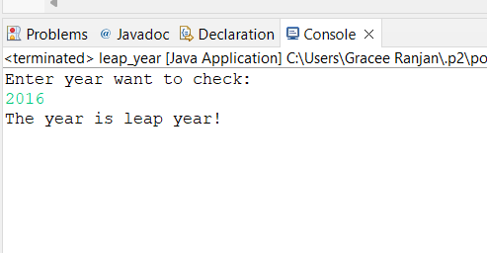

1. **Program for Grading System and take Subject Marks as input. Compute total, and Percentage and obtain Grade on the basis of below .**

**>=90 A Grade**

**<90  to 70 B Grade**

**<70 to 60 C Grade**

**<60 to 50 D Grade**

**F Grade**

**Ans:**

**import** java.util.Scanner;

**public** **class** studentmarks {

**public** **static** **void** main(String[] args) {

**float** [] marks = **new** **float**[5];

Scanner in = **new** Scanner(System.***in***);

System.***out***.println("Enter the marks of 5 subjects: ");

System.***out***.println();

**for**(**int** i=0;i<5;i++){

System.***out***.print("marks "+ (i+1)+" : ");

marks[i] = in.nextFloat();

}

**float** total_marks = (marks[0]+marks[1]+marks[2]+marks[3]+marks[4]);

**float** percentage = (total_marks/500)*100;

System.***out***.print("Your Grade is: ");

**if**(percentage>=90){

System.***out***.println("< A >");

}**else** **if**(percentage<90 && percentage>=70){

System.***out***.println("< B >");

}**else** **if**(percentage<70 && percentage>=60){

System.***out***.println("< C >");

}**else** **if**(percentage<60 && percentage>=50){

System.***out***.println("< D >");

}**else**{

System.***out***.println("< F >");

}

in.close();

System.***out***.println("Total marks obtained out of 500: "+total_marks);

System.***out***.println("Percentage: "+percentage+"% ");

}

}

**OUTPUT**

1. **Program implementing ATM Machine.**

**Ans:**

**import** java.util.Scanner;

**class** ATM {

**public** **static** **void** main(String[] args) {

//making an input buffer

Scanner in = **new** Scanner(System.***in***);

//defining variables

String user_name = "Gracee Ranjan";

**int** pin = 5749;

**long** bank_bal = 100000;

System.***out***.println("*********Welcome to ATM*********");

System.***out***.println("\nPlease enter your pin= ");

**int** tmp = in.nextInt();

**if** (tmp == pin){

System.***out***.println("\nWelcome, "+user_name);

//System.out.println("Your current bank balance is "+bank_bal);

**while**(**true**){

System.***out***.println("\nChoose from the options below: ");

System.***out***.println("1. Withdraw amount from savings.");

System.***out***.println("2. Deposit amount to savings.");

System.***out***.println("3. Check current balance.");

System.***out***.println("4. Exit");

System.***out***.println("Enter choice: ");

**int** ch = in.nextInt();

**if**(ch == 1){

System.***out***.println("Enter amount you want to withdraw: ");

**long** amount = in.nextLong();

**if**(bank_bal <= 0){

System.***out***.println("You have no bank balance to withdraw!!");

**continue**;

}

System.***out***.println("Please Enter your pin= ");

**int** tmp1 = in.nextInt();

**if** (tmp1 == pin){

bank_bal -= amount;

System.***out***.println("Operation sucessfull! ");

System.***out***.println("Your current bank balance is "+bank_bal);

}

**else**{

System.***out***.println("Transaction failed, wrong pin!!");

}

}

**else** **if**(ch==2){

System.***out***.println("Enter amount you want to deposit: ");

**long** amount = in.nextLong();

System.***out***.println("Please Enter your pin= ");

**int** tmp1 = in.nextInt();

**if** (tmp1 == pin){

bank_bal += amount;

System.***out***.println("Operation sucessfull! ");

System.***out***.println("Your current bank balance is "+bank_bal);

}

**else**{

System.***out***.println("Transaction failed, wrong pin!!");

}

}

**else** **if**(ch==3){

System.***out***.println("Please Enter your pin= ");

**int** tmp1 = in.nextInt();

**if** (tmp1 == pin){

System.***out***.println("Your current bank balance is "+bank_bal);

}

**else**{

System.***out***.println("Transaction failed, wrong pin!!");

}

}

**else**{

System.***out***.println("Thankyou, visit again!!");

**break**;

}

}

}

in.close();

}

}

**OUTPUT**

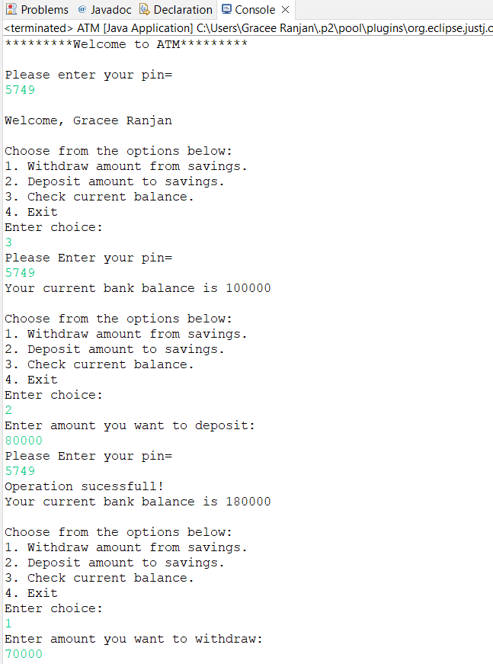

1. **Program for Hotel Menu System (If else, Switch Case)**

**Ans:**

**import** java.util.Scanner;

**public** **class** hostelfood {

**public** **static** **void** main(String[] args) {

String[] order = **new** String[9];

**int** choice;

**int** i=0;

Scanner in = **new** Scanner(System.***in***);

**while**(**true**){

System.***out***.println("\n************Welcome to Hotel*************");

System.***out***.println("\n\n--------Food Menu--------");

System.***out***.println("1. Aalo paratha");

System.***out***.println("2. Custard");

System.***out***.println("3. Momos");

System.***out***.println("4. Salad");

System.***out***.println("5. Paneer Bhurje");

System.***out***.println("6. Chicken Curry");

System.***out***.println("7. Masala Dosa");

System.***out***.println("8. Roti");

System.***out***.println("9. Exit");

System.***out***.println("\nPlease choose from the following: ");

choice = in.nextInt();

in.nextLine();

**switch**(choice){

**case** 1: order[i]="Aalo paratha";

++i;

**break**;

**case** 2: order[i]="Custard";

++i;

**break**;

**case** 3: order[i]="Momos";

++i;

**break**;

**case** 4: order[i]="Salad";

++i;

**break**;

**case** 5: order[i]="Paneer Bhurje";

++i;

**break**;

**case** 6: order[i]="Chicken Curry";

++i;

**break**;

**case** 7: order[i]="Masala Dosa";

++i;

**break**;

**case** 8: order[i]="Roti";

++i;

**break**;

**default**: **break**;

}

**if**(choice==9){

System.***out***.println(" Bon Appetit !! Thank You !!");

**break**;

}

System.***out***.println("\n*.*.*.*.*.*.The ordered list is:.*.*.*.*.*.* ");

**for**(**int** j=0;j<i;j++){

System.***out***.println(" "+(j+1)+". "+order[j]);

}

System.***out***.print("Want to enter more?(Y/N): ");

String ch = in.nextLine();

**if**(ch.equalsIgnoreCase("N")){

System.***out***.println("\n*.*.*.*.*.*.*.Your order is:.*.*.*.*.*.*.*");

**for**(**int** j=0;j<i;j++){

System.***out***.println(" "+(j+1)+". "+order[j]);

}

System.***out***.println("\nBon Appetit !! Thank You !! :)");

**break**;

}

}

in.close();

}

}

**OUTPUT**



